LAB 4 OUTPUTS

Q1. Write a program to compare two numbers and display the largest number using form application.

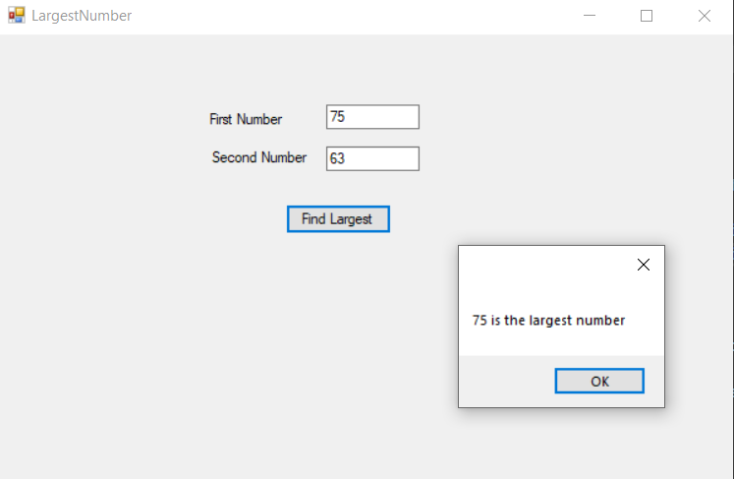

Q2. Write a program to find the factors of numbers in windows form application.

Q3. Make the windows as follows.

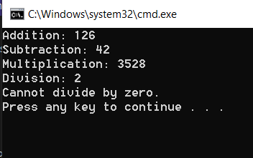

Q4. Write a C# program to print 1 to 10 using generic list.

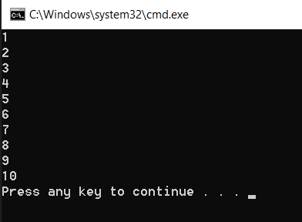

Q5. Write a C# program to print CustomerId and CustomerName using Dictionary.

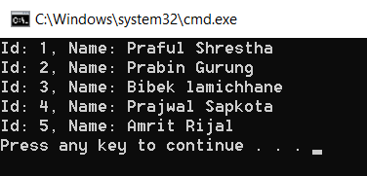

Q6. Write a C# program to sort given name using LINQ.

a. Ram,Shyam,Hari,Bikash,Mahesh

